MODULE 2: PAINTING WITH THE MOUSE

Agenda:
- Opening the MS Paint application (5 min)
- Choosing different brushes and tools (25 min)
- Drawing and erasing - undoing mistakes (25 min)
- Saving your creation (5 min)

Opening an application
On the Desktop (the main computer screen when no applications are open), look for the Paint application.
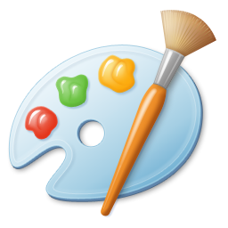
Move your mouse arrow over the icon and press the left button on the mouse once, so it becomes highlighted. Then press the Enter key on the keyboard to open the application.

Choosing different brushes and tools
Now that the application is open, move your mouse arrow so it is over the white canvas. Press down the left mouse button and hold it down as your move your mouse arrow around the canvas. You should see a black brush stroke appear wherever you moved the mouse.

Choosing a different size brush
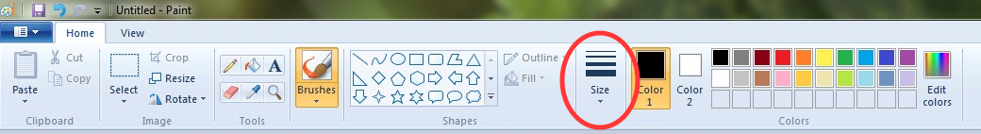
The menu bar
At the top of the application is the menu bar. This allows your to choose different tools and colors to paint with. Look for the icon that says “Size”. Click on the icon with the left mouse button. The menu should now show different size lines. Choose a thick line and try drawing on the canvas with your mouse again to see the results.

Choosing a different color
In the menu bar at the top, to the right of the “Size” icon, you will see grid of colors. You can change the color of your brush by clicking on a different color. Choose a color and try “painting” on that canvas again with your new color. Try a few combinations of different colors and different sizes.

Trying new paint tools
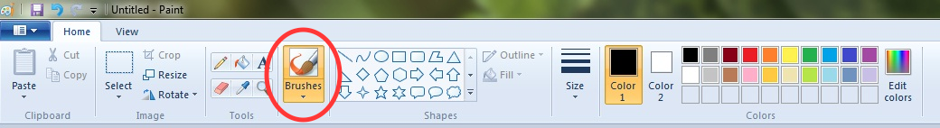
In the menu bar, look for an icon that says “Brushes”. Click with the left mouse button where it says “Brushes” and has the down arrow below it. A drop-down menu of options should appear. These are different “brush styles”. You’ll see options for an “oil brush”, “calligraphy pen”, “crayon”, “spray can”, and others. These different tools will change the types of marks you make when you click and drag (or “paint”) on the canvas below. Select one of these brush types and then “paint” on the canvas below.

Experiment with different brushes, colors, and sizes.

Drawing and erasing
By now, you should have a canvas filled with lots of colorful marks of various sizes. Maybe you think your canvas is very messy and you would like to clean it up.

In the menu bar at the top, look for the icon that is a pink rectangle just below the yellow pencil. This is the “Eraser” tool. Click on that icon with your mouse. Now use your mouse, just like before to “paint” on the canvas. This time you should see your previous marks getting erased. You can also change the size of the eraser to clean up your canvas much faster.

Erase your whole canvas and start drawing something new. With your mouse, click on the Brushes icon again and select the brush tool you like.

Try writing your name with each letter as a different color. If you make a mistake, click on the eraser icon again to erase the things you don’t like.

Saving your creation
When you are happy with the drawing you’ve made, it’s time to save it.

Saving a file in the Paint application is very similar to saving a file in almost any application.
In the top left corner of the application, look for the word “File” (it might just blue button with a down area). Click on it and you should see a menu of options appear. Click on “Save”.
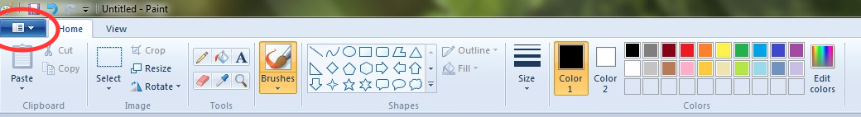

Now a box should appear which will allow you to choose a name for your drawing, and to choose a location on the computer where you want to save it. Use the keyboard to type your name. Once you have typed a name for your drawing, click Save.

Once you’ve saved your drawing you can close the Paint application. You can do this by finding the red ‘X’ in the top right corner of the application and clicking on it.

Exercise: Drawing with Paint
Use several of the techniques you just learned to make something original with the Paint application. Draw a face, or a landscape scene with trees and flowers, or a city building with windows, doors and a garden. Those are just some ideas to get you started. Feel free to paint whatever you like. Just be sure to use different colors, brush types and brush sizes to make your painting come to life!

Save your file on the desktop. You’ll share your creation with the group at the beginning of the next session.

